Somil Govani

Data Book and Version Change Log

2014-01-06 Somil Govani [somilgovani@gmail.com](mailto:somilgovani@gmail.com)

**Version 1.0 (Makenote: Note Variation)**

* + Implemented makenote and noteout objects
  + Added preset numbers

**Figure 1: Screenshot 1.0**

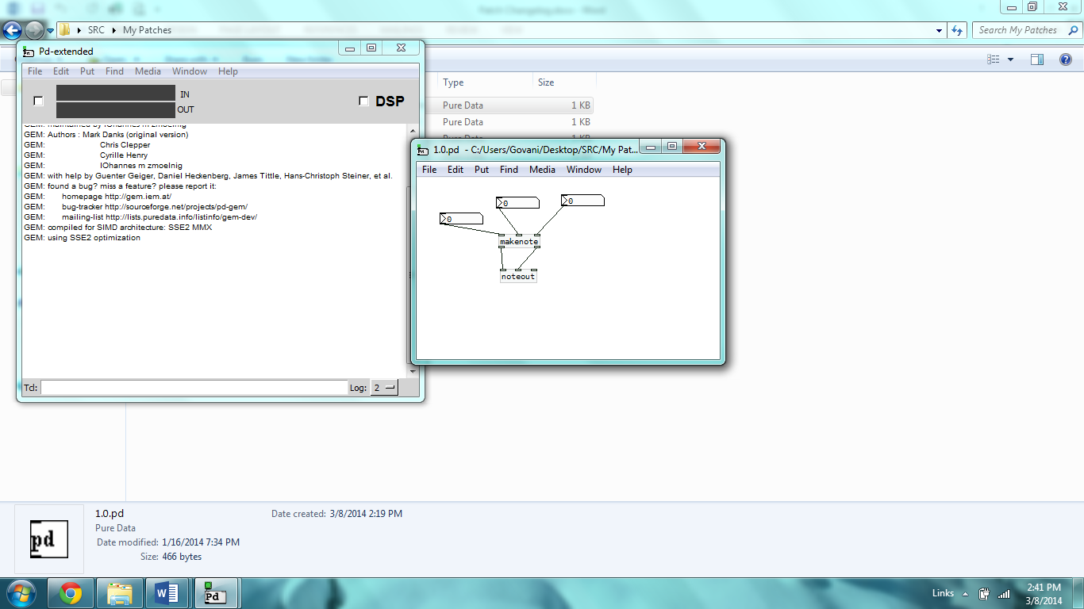

**Table – N/A**

2014-01-12 Somil Govani [somilgovani@gmail.com](mailto:somilgovani@gmail.com)

**Version 1.1 (Random Pitch)**

* Added random object to pitch branch

**Figure 2: Screenshot 1.1**

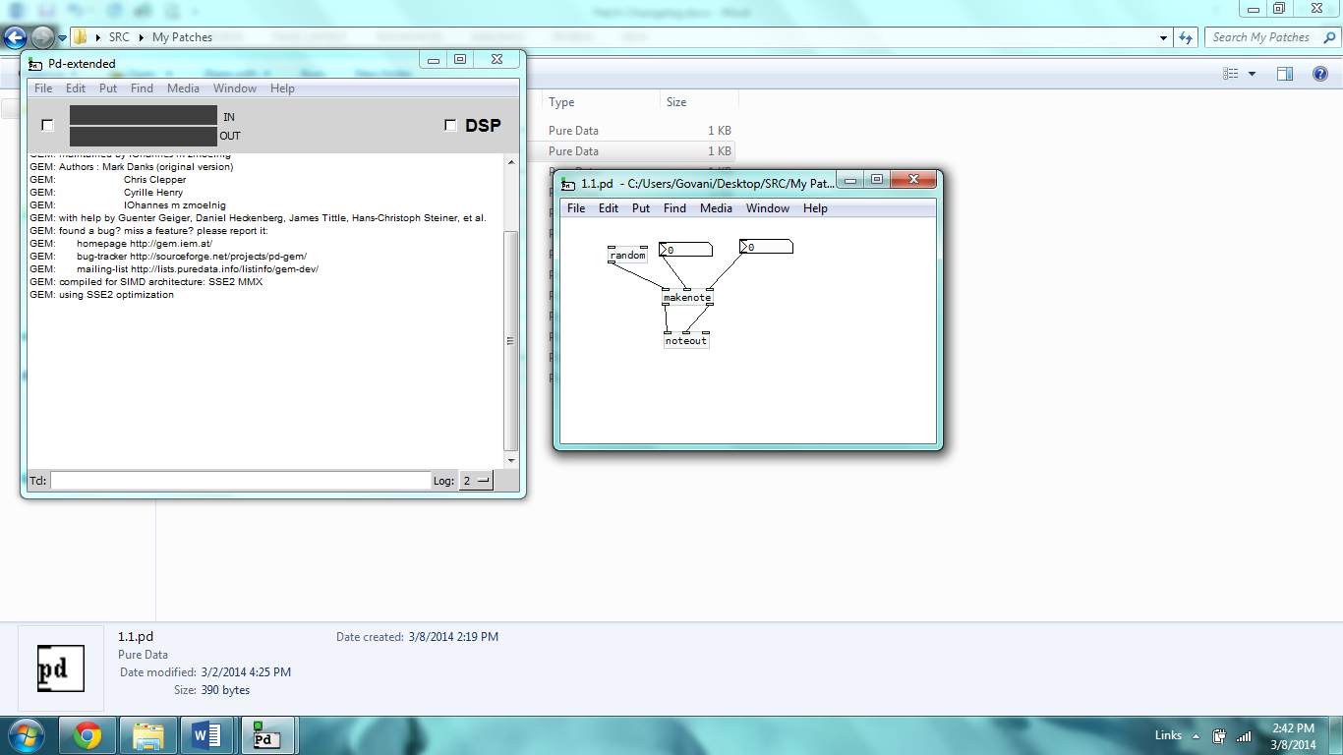

**Table – N/A**

2014-01-12 Somil Govani [somilgovani@gmail.com](mailto:somilgovani@gmail.com)

**Version 1.2 (Metro + Random Pitch)**

* Added Metronome Object to random pitch branch
* Set random max to 100
* Added print object to track results
* Added bang and stop objects

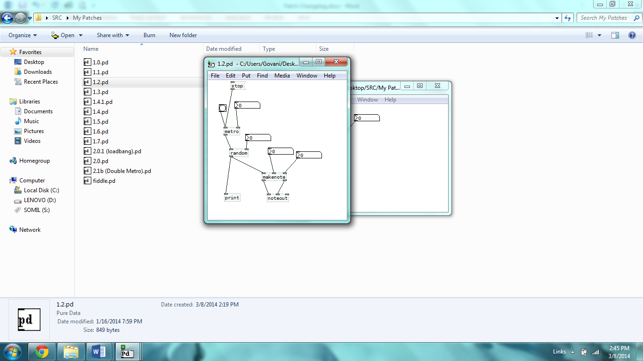**Figure 3: Screenshot 1.2**

**Table 1: Numerical Prints for 24 Pulses (1.2)**

|  |  |  |  |
| --- | --- | --- | --- |
| Note # | Pitch Frequency (Midi) | Velocity (Midi) | Duration (ms) |
| 1 | 69 | N/A | N/A |
| 2 | 46 |  |  |
| 3 | 52 |  |  |
| 4 | 21 |  |  |
| 5 | 4 |  |  |
| 6 | 8 |  |  |
| 7 | 56 |  |  |
| 8 | 97 |  |  |
| 9 | 77 |  |  |
| 10 | 64 |  |  |
| 11 | 79 |  |  |
| 12 | 52 |  |  |
| 13 | 87 |  |  |
| 14 | 37 |  |  |
| 15 | 95 |  |  |
| 16 | 41 |  |  |
| 17 | 20 |  |  |
| 18 | 33 |  |  |
| 19 | 29 |  |  |
| 20 | 67 |  |  |
| 21 | 82 |  |  |
| 22 | 11 |  |  |
| 23 | 35 |  |  |
| 24 | 11 |  |  |

2014-01-12 Somil Govani [somilgovani@gmail.com](mailto:somilgovani@gmail.com)

**Version 1.3 (Frequency Parameters: 48-98)**

* Added “+48” object succeeding random
* Set max random to 50
* Frequency of pitches set to 48-98

**Figure 4: Screenshot 1.3**

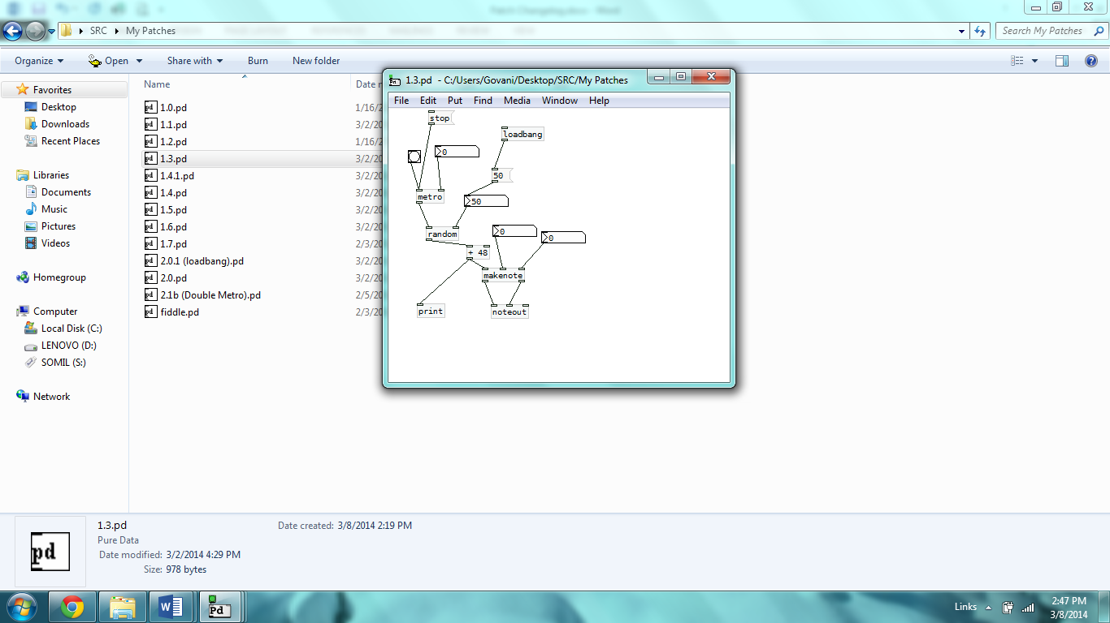

**Table 2: Numerical Prints for 24 Pulses (1.3)**

|  |  |  |  |
| --- | --- | --- | --- |
| Note # | Pitch Frequency (Midi) | Velocity (Midi) | Duration (ms) |
| 1 | 51 | N/A | N/A |
| 2 | 77 |  |  |
| 3 | 89 |  |  |
| 4 | 52 |  |  |
| 5 | 62 |  |  |
| 6 | 90 |  |  |
| 7 | 66 |  |  |
| 8 | 85 |  |  |
| 9 | 57 |  |  |
| 10 | 62 |  |  |
| 11 | 85 |  |  |
| 12 | 75 |  |  |
| 13 | 95 |  |  |
| 14 | 89 |  |  |
| 15 | 97 |  |  |
| 16 | 96 |  |  |
| 17 | 58 |  |  |
| 18 | 64 |  |  |
| 19 | 60 |  |  |
| 20 | 59 |  |  |
| 21 | 77 |  |  |
| 22 | 65 |  |  |
| 23 | 81 |  |  |
| 24 | 70 |  |  |

2014-01-18 Somil Govani [somilgovani@gmail.com](mailto:somilgovani@gmail.com)

**Version 1.4 (Random 27 + Cmajor Scale)**

* Cmajor array/table 27 notes sent to tabread (4 octaves high [3-6])
* Random limited to 27 notes (4 octaves [3-6])

**Figure 5: Screenshot 1.4**

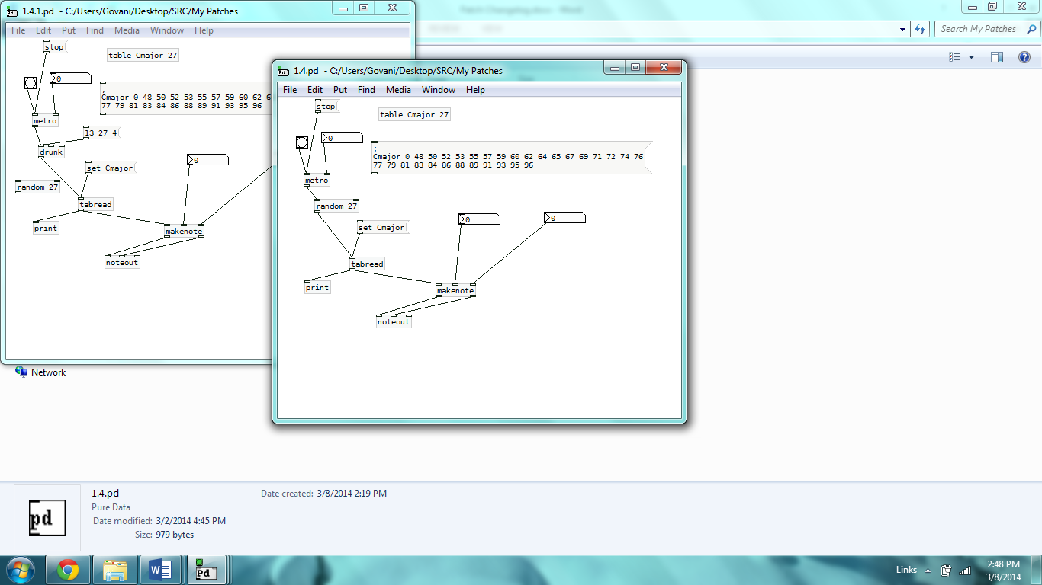

**Table 3: Numerical Prints for 24 Pulses (1.4)**

|  |  |  |  |
| --- | --- | --- | --- |
| Note # | Pitch Frequency (Midi) | Velocity (Midi) | Duration (ms) |
| 1 | 48 | N/A | N/A |
| 2 | 62 |  |  |
| 3 | 53 |  |  |
| 4 | 89 |  |  |
| 5 | 53 |  |  |
| 6 | 50 |  |  |
| 7 | 79 |  |  |
| 8 | 62 |  |  |
| 9 | 91 |  |  |
| 10 | 72 |  |  |
| 11 | 79 |  |  |
| 12 | 52 |  |  |
| 13 | 60 |  |  |
| 14 | 86 |  |  |
| 15 | 65 |  |  |
| 16 | 60 |  |  |
| 17 | 48 |  |  |
| 18 | 55 |  |  |
| 19 | 83 |  |  |
| 20 | 83 |  |  |
| 21 | 79 |  |  |
| 22 | 77 |  |  |
| 23 | 69 |  |  |
| 24 | 71 |  |  |

2014-01-18 Somil Govani [somilgovani@gmail.com](mailto:somilgovani@gmail.com)

**Version 1.4.1 (Drunk)**

* Random replaced with drunk in pitch branch
* Drunk set to 13 index, 27 max, 4 jump

**Figure 6: Screenshot 1.4.1**

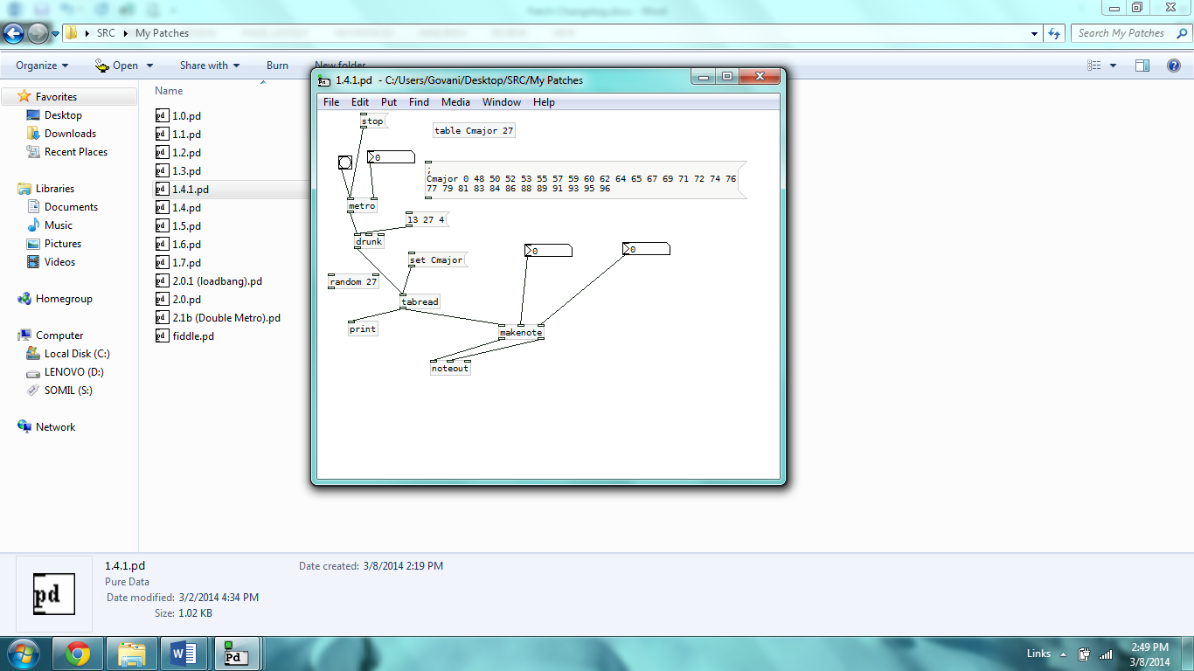

**Table 4: Numerical Prints for 24 Pulses (1.4.1)**

|  |  |  |  |
| --- | --- | --- | --- |
| Note # | Pitch Frequency (Midi) | Velocity (Midi) | Duration (ms) |
| 1 | 71 | N/A | N/A |
| 2 | 67 |  |  |
| 3 | 62 |  |  |
| 4 | 57 |  |  |
| 5 | 55 |  |  |
| 6 | 55 |  |  |
| 7 | 53 |  |  |
| 8 | 52 |  |  |
| 9 | 53 |  |  |
| 10 | 59 |  |  |
| 11 | 62 |  |  |
| 12 | 65 |  |  |
| 13 | 65 |  |  |
| 14 | 65 |  |  |
| 15 | 71 |  |  |
| 16 | 71 |  |  |
| 17 | 67 |  |  |
| 18 | 67 |  |  |
| 19 | 67 |  |  |
| 20 | 62 |  |  |
| 21 | 59 |  |  |
| 22 | 59 |  |  |
| 23 | 59 |  |  |
| 24 | 60 |  |  |

2014-01-27 Somil Govani [somilgovani@gmail.com](mailto:somilgovani@gmail.com)

**Version 1.5 (Randomize Attack)**

* Velocity branch set from 90-127
* Linked to metronome
* Drunk max limited to 20

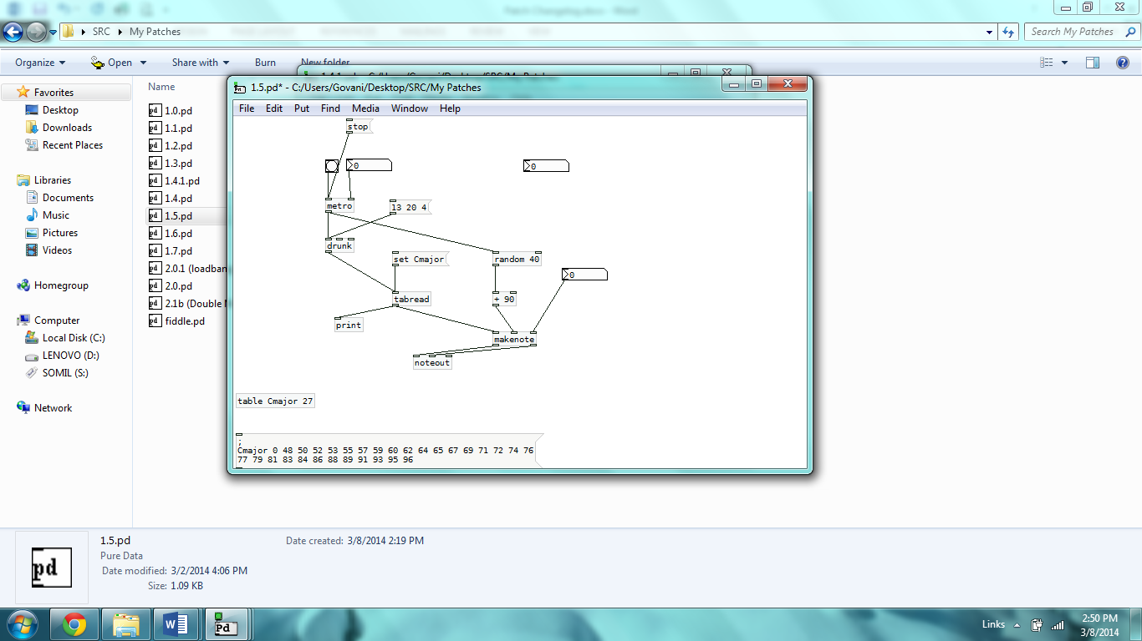**Figure 7: Screenshot 1.5**

**Table 5: Numerical Prints for 24 Pulses (1.5)**

|  |  |  |  |
| --- | --- | --- | --- |
| Note # | Pitch Frequency (Midi) | Velocity (Midi) | Duration (ms) |
| 1 | 71 | 119 | N/A |
| 2 | 65 | 112 |  |
| 3 | 60 | 120 |  |
| 4 | 65 | 109 |  |
| 5 | 62 | 112 |  |
| 6 | 65 | 118 |  |
| 7 | 62 | 97 |  |
| 8 | 65 | 118 |  |
| 9 | 65 | 126 |  |
| 10 | 65 | 90 |  |
| 11 | 67 | 93 |  |
| 12 | 72 | 125 |  |
| 13 | 69 | 106 |  |
| 14 | 64 | 123 |  |
| 15 | 59 | 113 |  |
| 16 | 59 | 109 |  |
| 17 | 59 | 97 |  |
| 18 | 60 | 104 |  |
| 19 | 64 | 104 |  |
| 20 | 67 | 92 |  |
| 21 | 65 | 103 |  |
| 22 | 65 | 101 |  |
| 23 | 69 | 120 |  |
| 24 | 74 | 102 |  |

2014-01-27 Somil Govani [somilgovani@gmail.com](mailto:somilgovani@gmail.com)

**Version 1.6 (Randomize Duration)**

* Used 3 durations (500, 1000, 3000 ms)
* 500 and 1000 used twice each
* Linked duration branch to metro, random 5, tabread

**Figure 8: Screenshot 1.6**

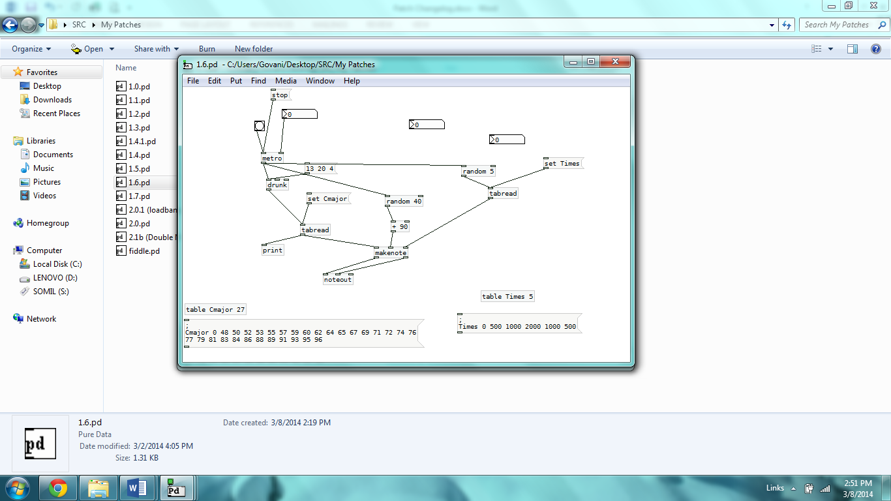

**Table 6: Numerical Prints for 24 Pulses (1.6)**

|  |  |  |  |
| --- | --- | --- | --- |
| Note # | Pitch Frequency (Midi) | Velocity (Midi) | Duration (ms) |
| 1 | 71 | 115 | 500 |
| 2 | 71 | 92 | 500 |
| 3 | 67 | 126 | 500 |
| 4 | 62 | 109 | 500 |
| 5 | 67 | 91 | 1000 |
| 6 | 65 | 109 | 1000 |
| 7 | 60 | 94 | 2000 |
| 8 | 55 | 103 | 1000 |
| 9 | 50 | 124 | 500 |
| 10 | 53 | 101 | 1000 |
| 11 | 55 | 117 | 2000 |
| 12 | 55 | 111 | 500 |
| 13 | 52 | 107 | 1000 |
| 14 | 57 | 93 | 500 |
| 15 | 57 | 97 | 2000 |
| 16 | 57 | 126 | 500 |
| 17 | 52 | 121 | 1000 |
| 18 | 55 | 98 | 500 |
| 19 | 55 | 106 | 500 |
| 20 | 52 | 120 | 500 |
| 21 | 52 | 91 | 1000 |
| 22 | 57 | 108 | 500 |
| 23 | 59 | 111 | 1000 |
| 24 | 60 | 90 | 2000 |

2014-01-28 Somil Govani [somilgovani@gmail.com](mailto:somilgovani@gmail.com)

**Version 1.7 (Polyphony)**

* Sent metro (m), duration (t), velocity (v)
* Built parallel make note structure receive m, t, v
* Cmajor bass table added (22 values) (2 octaves low [2-3])
* Drunk index 11 max 22 step 2 to select from bass notes
* Replaced drunk in melody with random again

**Figure 9: Screenshot 1.7**

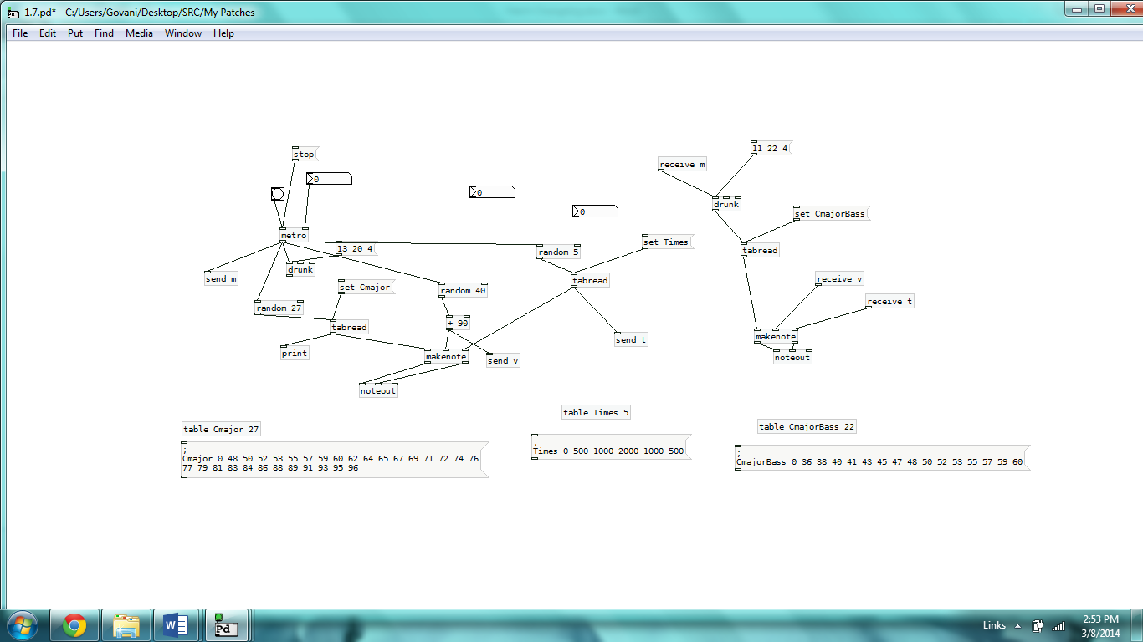

**Table 7: Numerical Prints for 24 Pulses (1.7)**

|  |  |  |  |  |  |  |
| --- | --- | --- | --- | --- | --- | --- |
| Note # | Pitch Frequency (Midi) | Velocity (Midi) | Duration (ms) | Bass Frequency (Midi) | Bass Velocity (Midi) | Bass Duration (ms) |
| 1 | 65 | 127 | 1000 | 52 | Same as left | Same as left |
| 2 | 64 | 111 | 500 | 52 |  |  |
| 3 | 93 | 90 | 2000 | 52 |  |  |
| 4 | 48 | 117 | 500 | 52 |  |  |
| 5 | 62 | 105 | 2000 | 52 |  |  |
| 6 | 84 | 92 | 2000 | 48 |  |  |
| 7 | 77 | 118 | 2000 | 43 |  |  |
| 8 | 53 | 116 | 1000 | 43 |  |  |
| 9 | 91 | 121 | 1000 | 45 |  |  |
| 10 | 77 | 111 | 500 | 40 |  |  |
| 11 | 55 | 90 | 500 | 45 |  |  |
| 12 | 64 | 101 | 500 | 43 |  |  |
| 13 | 60 | 127 | 1000 | 43 |  |  |
| 14 | 77 | 100 | 1000 | 40 |  |  |
| 15 | 55 | 99 | 500 | 40 |  |  |
| 16 | 93 | 93 | 1000 | 45 |  |  |
| 17 | 79 | 95 | 500 | 43 |  |  |
| 18 | 48 | 109 | 500 | 45 |  |  |
| 19 | 62 | 126 | 500 | 40 |  |  |
| 20 | 77 | 110 | 1000 | 40 |  |  |
| 21 | 83 | 116 | 1000 | 45 |  |  |
| 22 | 67 | 106 | 2000 | 50 |  |  |
| 23 | 74 | 124 | 500 | 45 |  |  |
| 24 | 76 | 104 | 2000 | 41 |  |  |

2014-02-02 Somil Govani [somilgovani@gmail.com](mailto:somilgovani@gmail.com)

**Version 2.0**

* Fixed miscounts
  + Cmajor (melody) has *29* values
  + CmajorBass has *15* values
  + Changed drunks, random to match
* Times table/array updated with *14* values
  + Added silence
  + Added probability aesthetics – 0s to 500s to 1000s to 2000s = 1:7:4:2
  + 0 = silence
  + Equivalent to bass structure
* Added Bb Blues Scale (Melody and Bass)
  + Melody – 4 octaves, added two notes to equal n-value of Cmajor for randomization compatibility
  + Bass – 2 octaves, same as above
* Changed velocity to 60-100 midi values
* Replaced receive velocity with independent parameters

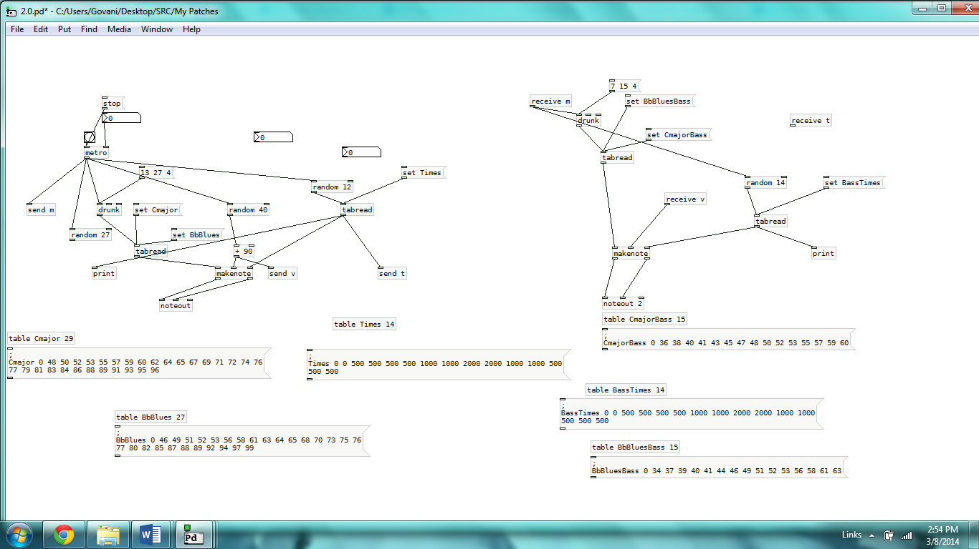

Figure 10: Screenshot 2.0/2.0.1

**Table 8: Numerical Prints for 24 Pulses (2.0)**

|  |  |  |  |  |  |  |
| --- | --- | --- | --- | --- | --- | --- |
| Note # | Pitch Frequency (Midi) | Velocity (Midi) | Duration (ms) | Bass Frequency (Midi) | Bass Velocity (Midi) | Bass Duration (ms) |
| 1 | 69 | 97 | 1000 | 50 | 79 | 500 |
| 2 | 65 | 80 | 1000 | 45 | 98 | 1000 |
| 3 | 65 | 85 | 1000 | 50 | 64 | 2000 |
| 4 | 64 | 68 | 0 | 50 | 69 | 500 |
| 5 | 64 | 92 | 0 | 52 | 79 | 1000 |
| 6 | 62 | 67 | 500 | 52 | 86 | 500 |
| 7 | 62 | 95 | 1000 | 53 | 89 | 500 |
| 8 | 62 | 85 | 2000 | 53 | 93 | 2000 |
| 9 | 65 | 91 | 500 | 52 | 78 | 2000 |
| 10 | 64 | 82 | 500 | 50 | 78 | 500 |
| 11 | 64 | 90 | 1000 | 47 | 76 | 500 |
| 12 | 62 | 95 | 500 | 43 | 87 | 2000 |
| 13 | 62 | 91 | 1000 | 47 | 84 | 1000 |
| 14 | 57 | 82 | 2000 | 41 | 80 | 1000 |
| 15 | 52 | 71 | 1000 | 40 | 89 | 500 |
| 16 | 52 | 62 | 0 | 38 | 72 | 1000 |
| 17 | 52 | 69 | 1000 | 43 | 60 | 500 |
| 18 | 50 | 88 | 0 | 40 | 83 | 500 |
| 19 | 55 | 88 | 500 | 40 | 73 | 500 |
| 20 | 55 | 81 | 500 | 38 | 96 | 500 |
| 21 | 55 | 87 | 500 | 38 | 60 | 0 |
| 22 | 52 | 92 | 500 | 40 | 90 | 0 |
| 23 | 50 | 76 | 1000 | 40 | 87 | 2000 |
| 24 | 50 | 69 | 1000 | 41 | 94 | 2000 |

2014-02-02 Somil Govani [somilgovani@gmail.com](mailto:somilgovani@gmail.com)

**Version 2.0.1 (Loadbang)**

* Added loadbang to all messages for ease of start
* Made default metro “315”
* Minor bug fix of infinite note value mismatch problem

**Screenshot: Same as 2.0, but with Loadbang**

**See Table 8**

2014-02-16 Somil Govani [somilgovani@gmail.com](mailto:somilgovani@gmail.com)

**Version 2.1b (Crescendos & Decrescendos)**

* Used “Double Metronome” to graduate tempo

**Figure 11: Screenshot 2.1b (only double metro part)**

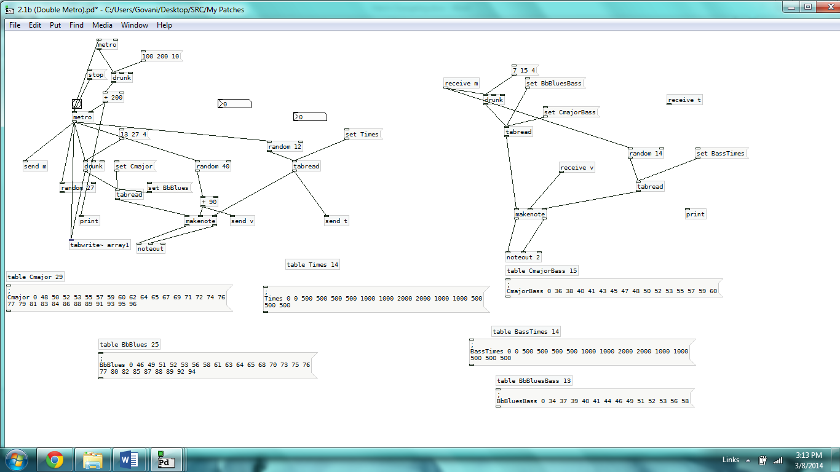

**Table 9: Numerical Prints for 20 Pulses (Metro) (2.1b)**

|  |  |
| --- | --- |
| Double Metro (Tempo in pulse/ms) | |
| 300 | 267 |
| 297 | 274 |
| 292 | 281 |
| 286 | 286 |
| 277 | 294 |
| 268 | 298 |
| 267 | 298 |
| 261 | 292 |
| 259 | 284 |
| 260 | 277 |